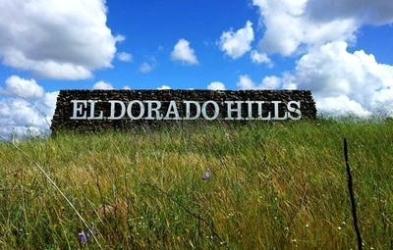
EL DORADO HILLS HAPPENINGS

Every Sunday (now year-round!) EDH Farmers market, 9am-1pm, EDH Town Center, behind Nibblers and Trek bicycle.
July 3 – Fireworks and Freedom concert, 6-11pm, EDH Town Center Amphitheatre. Enjoy live music, great food and drinks, and special vendors. Entertain the kids in the Kids Zone complete with bounce houses, face painting, balloon artists, and a DJ playing games and giving away prizes. The Freedom Concert starts at 8pm in the Steven Young Amphitheater and the evening will conclude with a spectacular new Fireworks display.
July 4 – 4th of July at Community pool, 1-4pm, EDH CSD pool, they will have music, decorations, games
July10-July 31 – EDH Library Art Wednesdays, 10-11:30 am, EDH Library. Open to artists of all ages.
7/10 — Feather Play
7/17 — Paper Plate Kites
7/24 — Suncatchers
7/31 — Nature Jewelry
July 11 – Jordan the Science Wizard, 10:30-11:30, EDH library, experience the most incredible chemistry show ever, including melting, oozing, smoking, and bubbling! This program is held as part of Adventure Begins at the Library: Summer Reading Challenge 2024
July 11-September 5 – “Live on the Boulevard” concert series, every Thursday, 7-9pm, EDH Town Center Amphitheater
July 18 – Community Helpers: Fire Fighters, 10:30-11:30, EDH library, Learn about fire safety when El Dorado County Fire Fighters come to visit the library. You'll even get to see the fire truck up close!
July 19 – Summer concert series, EDH CSD park, 7-9:30pm
July 25 – Taiko Dan Drummers, 10:30-11:30am, EDH library. Experience the ancient artform of the Japanese taiko drum! Sacramento Taiko Dan is bringing a thrilling performance featuring incredible music and choreographed movement. Held outdoors at the gazebo by the pond, so patrons are encouraged to bring lawn chairs or blankets to sit on.

