**CalAgPermits: Monthly Pesticide Use Report – Production Ag Growers/Operators**

The **Monthly Ag Pesticide Use Report (PUR) for Grower Applications** is the PUR form a majority of permittees use. Select when reporting pesticides used on agricultural commodities (such as wine grapes or fruit trees) and pesticides used for weed abatement.

On the home page, start a new report in the section labeled **“Ag PURs.”** Click on **“Enter a new Monthly Report for Grower Applications.”** 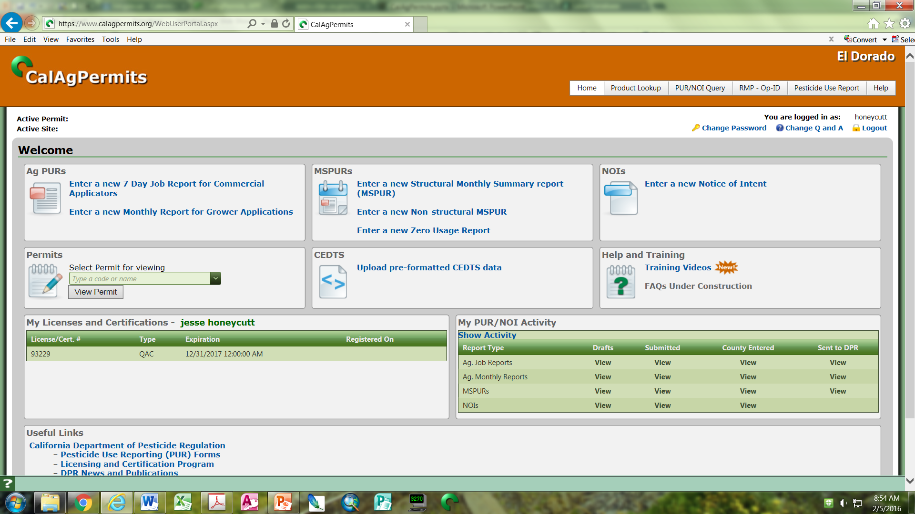

This opens the website’s online report form where you can fill in information from your application(s). Start at the top of the page and fill in all of the orange boxes. The green boxes are optional. If a box has a down arrow, click on it to select your permit from the drop down menu. You can also type information into the box to limit your options, then select the correct entry.

1. Click on the down arrow and select your “**Operator ID**/**Permit #**”from the drop down menu.

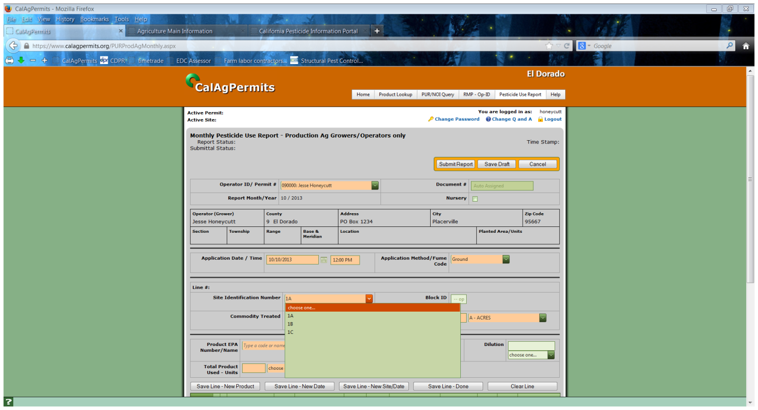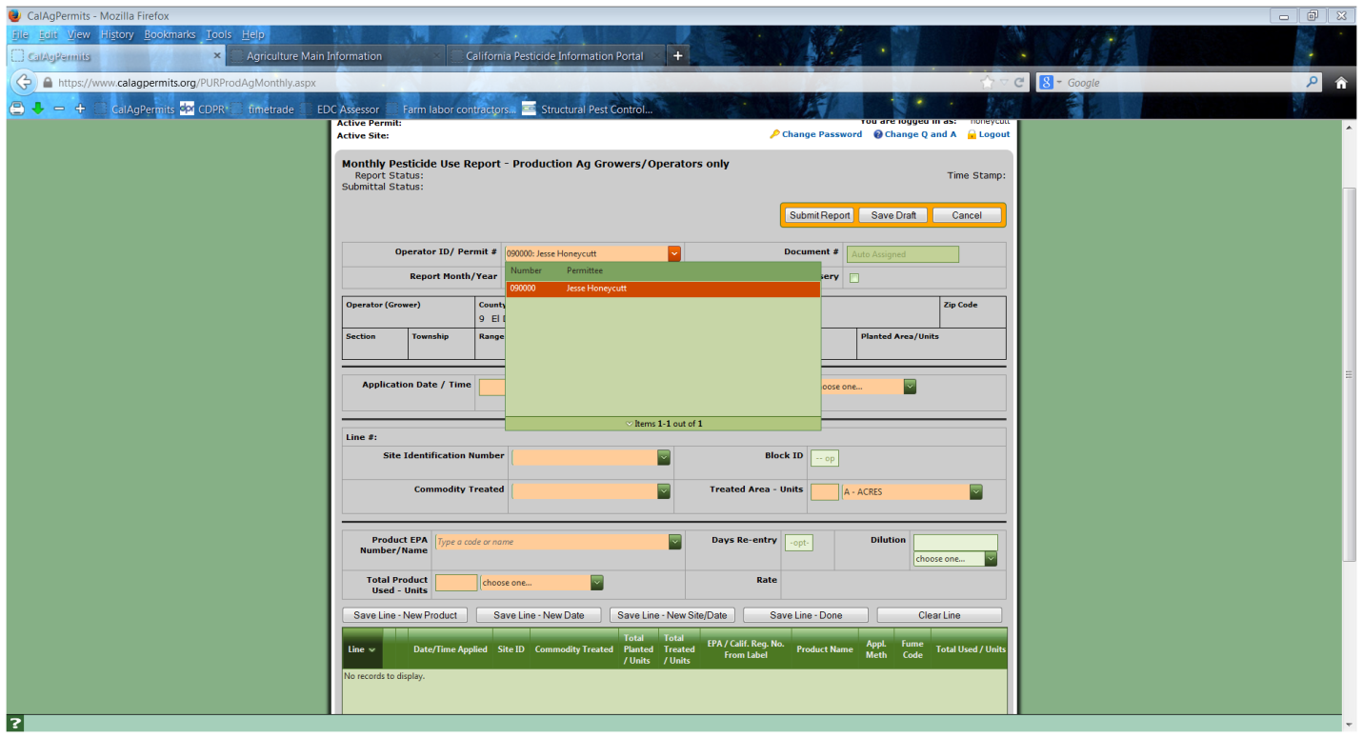

2. As you select items from the drop down menus and type in your information some gray fields, “**Operator (Grower)**”/“**Address**” etc., will populate automatically with information from your permit.

3. Type or use the calendar icon to fill in the “**Application Date**” and “**Time.**”

5. Click on the down arrow and select the “**Site Identification Number**” for the applicable pesticide application site. At this time “**Commodity Treated**” will auto fill if you have only one commodity per site, otherwise, use the drop down to select the correct commodity.

4. When choosing from the “**Application Method/Fume Code**” drop down menu, nearly all pesticide applications will be “**Ground**.”

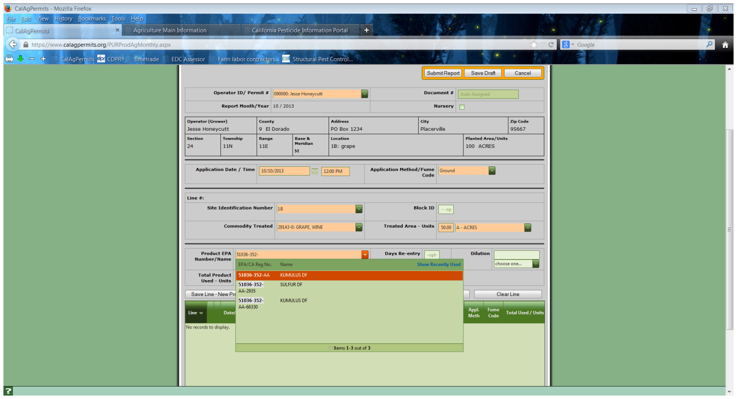

6. Type in the treated area size then choose the correlating unit(s).

7. Type either the EPA Reg. No. or the product name of the pesticide used in the “**Product EPA Number/Name**” box. Please be patient as the search function references tens of thousands of registered pesticides. Click on the correct pesticide to fill the box. Double check that the pesticide name/number is the same as the one on your label, many are very similar.

8. Next enter the amount of pesticide used.

9. Once all of the required information has been filled in, you need to save each line by clicking on one of the four white **“Save Line”** buttons. Each of these buttons will save your application line below the green “**Line**” bar. The difference is how much information in the orange boxes will be cleared for your next application line. This is a time saving feature.

“**Clear Line**” clears any information in the orange boxes. It does NOT erase the pesticide application lines beneath the green “**Line**” bar.

“**Save Line-Done**” clears any residual information in the orange boxes so the report can be saved and/or submitted.

“**Save Line-New Site/Date**”

retains only the information in the fields above “**Application Date/Time**.”

“**Save Line-New Date**”

retains all information except pesticide used, amount, and date.

“**Save Line-New Product**”

retains all information in the orange boxes except the pesticide used and amount.

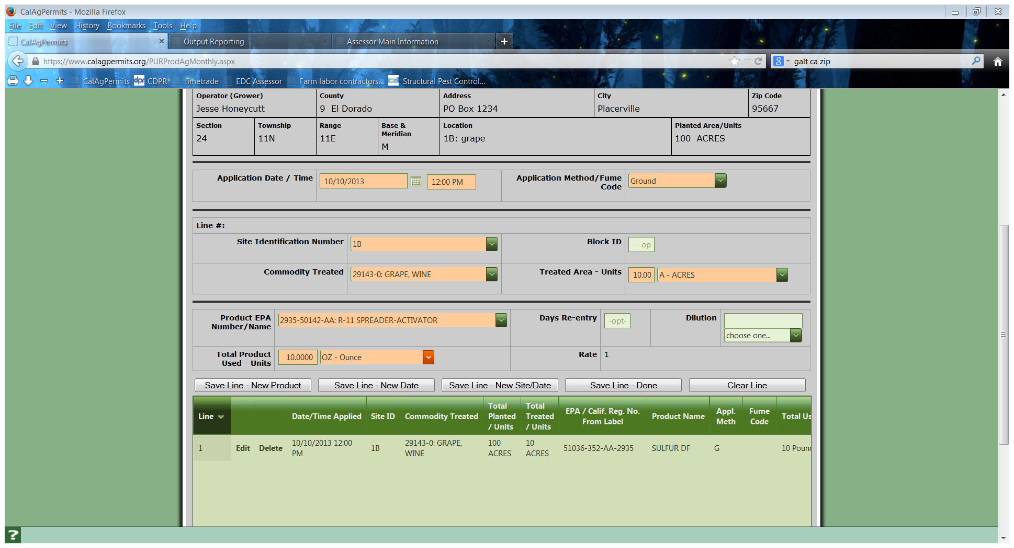

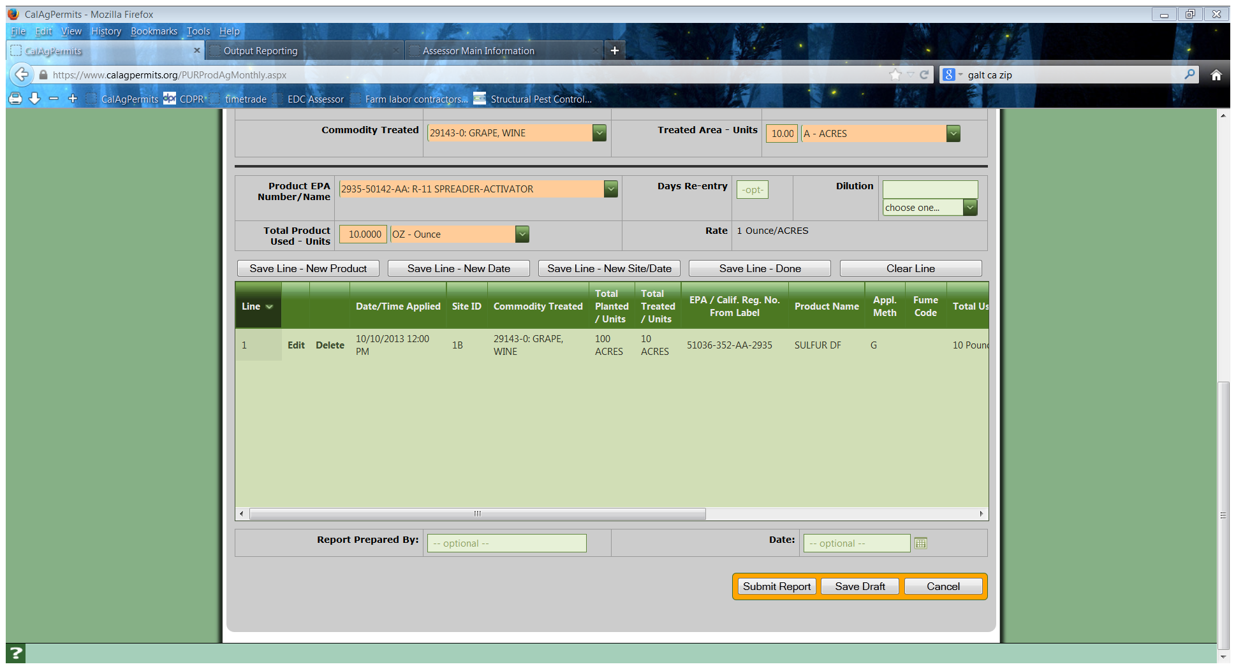

10. After saving the last pesticide application line, either click on “**Submit Report**” or “**Save Draft**” at the top or bottom of the screen. NOTE: *If you’re not finished with the report and want to work on it at a later time, click “****Save Draft.****” However, this does NOT submit the report to the County. You must go back, reopen the Ag PUR and click “****Submit Report****” to submit.*

11. This is the PUR overview page that is visible after a PUR is saved as a draft or submitted to the county. A correctly saved report will have a “Submitted to County” or “DPR” for Submittal Status (see the PUR main page for a status abbreviation legend). Un-submitted reports, drafts, have a “Not Submitted” status.

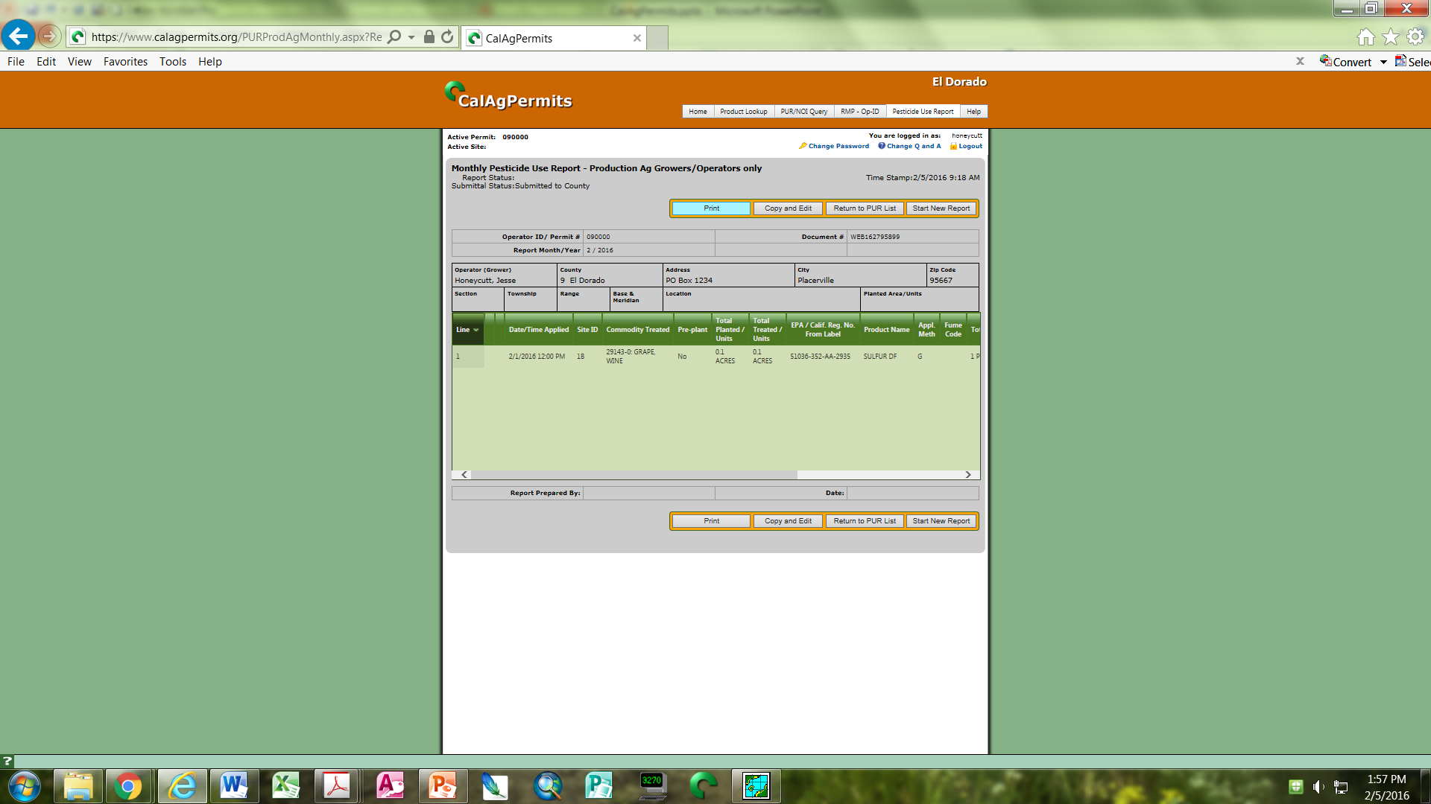

Note: There’s a “Copy and Edit” button. This is useful for applicators using the same pesticides every month. Clicking on this makes a duplicate of the use report you have open. To update it, click on each line and put in the new application date and amount applied.

Below is the PUR main page. It shows all of PURs attached to your permit. At present, there are several Monthly Ag PURs. They’re error free and have all been submitted.

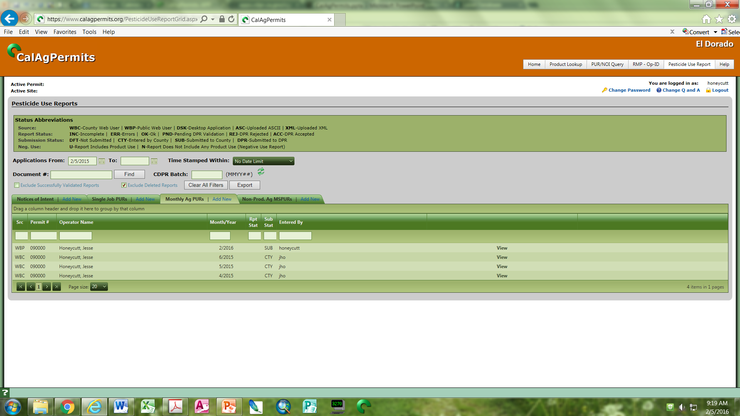

From here you can click on “**View**” to look at, edit, or submit this PUR.

If this PUR is erroneous, you may click “**Delete**” to erase it. *Note: If you have submitted the report you will not be able to edit or delete.*