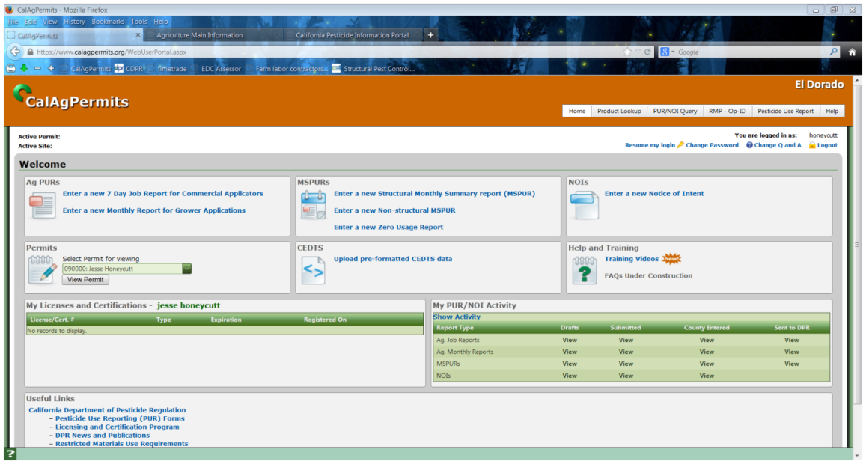**CalAgPermits: Notice of Intent (NOI)**

Restricted Material permit holders are required to submit a Notice of Intent (NOI)prior to applying California restricted materials. Permittees can file their NOIs online directly to the County Agricultural Commissioner’s Office using CalAgPermits.

1. Begin a new Notice of Intent by going to the Home Page and clicking on “**Enter a new Notice of Intent**”.

**-This will open the screen below-**

2. Start at the top of the page and fill in all mandatory orange boxes. The green boxes are optional. If a box has a small green arrow, you can click on it and select your information from the drop down menu.

3. Enter the “**Date/Time of Proposed Application**.”

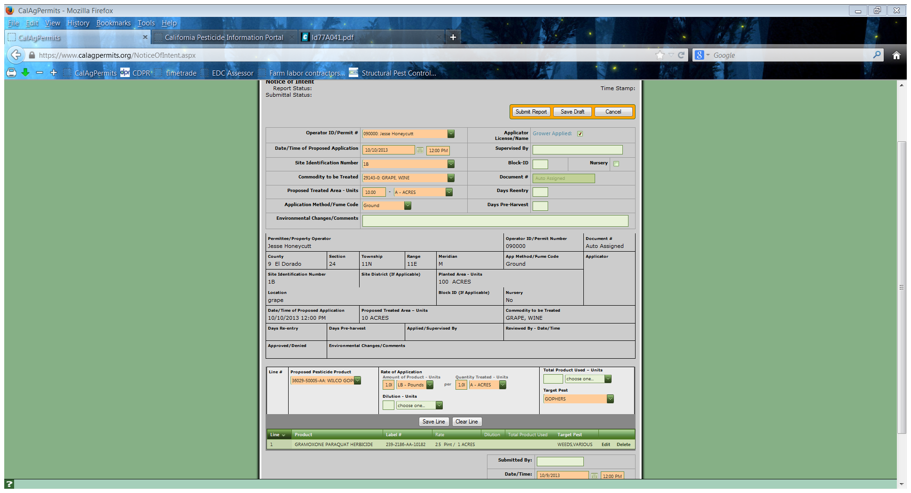4. As you select items from the drop down menus and type in your information, many of the other fields (“**Permittee**/ **Property Operator**,”etc.) will be populated automatically with your information.

5. Include the “**Proposed Pesticide Product”** (w/ EPA Reg. No.), “**Rate of Application**” and “**Target Pest**”.

6. Once all of the orange boxes have been filled in, save each line by clicking on the **“Save Line”** button. Saved lines will appear in the lower green area. The line can be Edited or Deleted before the NOI is submitted.

7. Be sure to include your name and date of submission.

8. Once all of the lines have been correctly added to the form, and you are ready to send the completed NOI to the County as an official document, click **“Submit Report.”** A pop up screen will appear stating “Your form was successfully submitted to the county.”If the line is not filled out completely or has obvious mistakes, an error message will pop up instead. Always follow the prompts and correct mistakes. Uncorrected errors result in automatic drafts. Check “Submittal Status:” in the upper left of the screen to see if the NOI has been correctly submitted. If so, a “Submitted to County” will appear. “Report Status:” will remain blank. To see if the NOI has been approved, go to the Pesticide Use Report main screen and look under the NOI tab. In the green bar is “Rvw Stat.” An “APP” will appear beneath this bar once the NOI has been reviewed and accepted by a county biologist.

The notice will also be saved automatically and available for you to review at anytime.

NOTE: *If you are not finished with the report and want to continue working on it at a later time, click* ***“Save Draft.”*** *Remember, however, this does NOT submit the report to the County. You will have to go back and do that later.*