**CalAgPermits: Signing On Username:**

***Introduction:* Temporary Password:**

Thank you for your interest in the new CalAgPermits Web-Based (Online) System. This is a free service intended to simplify and streamline the existing permit and pesticide reporting process.

As a CalAgPermits Web-User you will be able to view information about your permit, review historical data related to your Pesticide Use Reports (PUR) and submit PURs and Notices of Intent (NOI) online directly to the County Agricultural Commissioner’s Office. You will also be able to access and use the complete *User’s Guide* under the *Help* drop down menu, which provides more detailed information about this application and how to use it. In the meantime, this handout will offer a quick and easy introduction to help you access the system.

***Setting Up Your Account:***

Before you can begin using the CalAgPermits website, the County Agricultural Commissioner’s Office must set up your own Web-User account and link it to your existing permit. If you do not already have a Web-User account for our county, please contact our office as soon as possible. It only takes a few minutes and we can set up most accounts over the phone or by email.

Once your account has been established you will be given a **Username** and **Temporary Password**. The first time you log in you will be asked to change your Temporary Password to your own Permanent Password.

***Logging In To Your Account:***

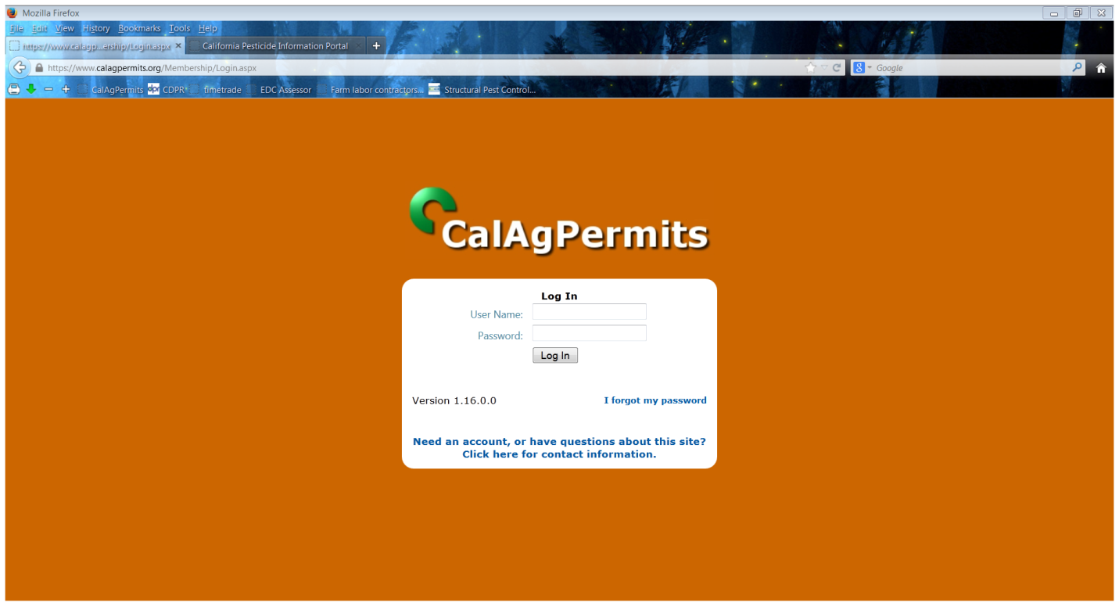Using your web browser, navigate to the CalAgPermits web site at: http://www.calagpermits.org

1. Enter your “**User Name”** and “**Password”** in the boxes provided.
2. Then click “**Log In”**
3. From here you will be taken to the **Home Page**.

**7 Day Job PUR**: This is used by Ag pest control businesses or applicators for hire for reporting site by site, day by day, single pesticide applications. Form must be submitted within 7 days of application.

**Monthly Ag PUR**: This is what a majority of permittees use. Select when reporting pesticides used on agricultural commodities (such as wine grapes or fruit trees) and pesticides used for weed abatement.

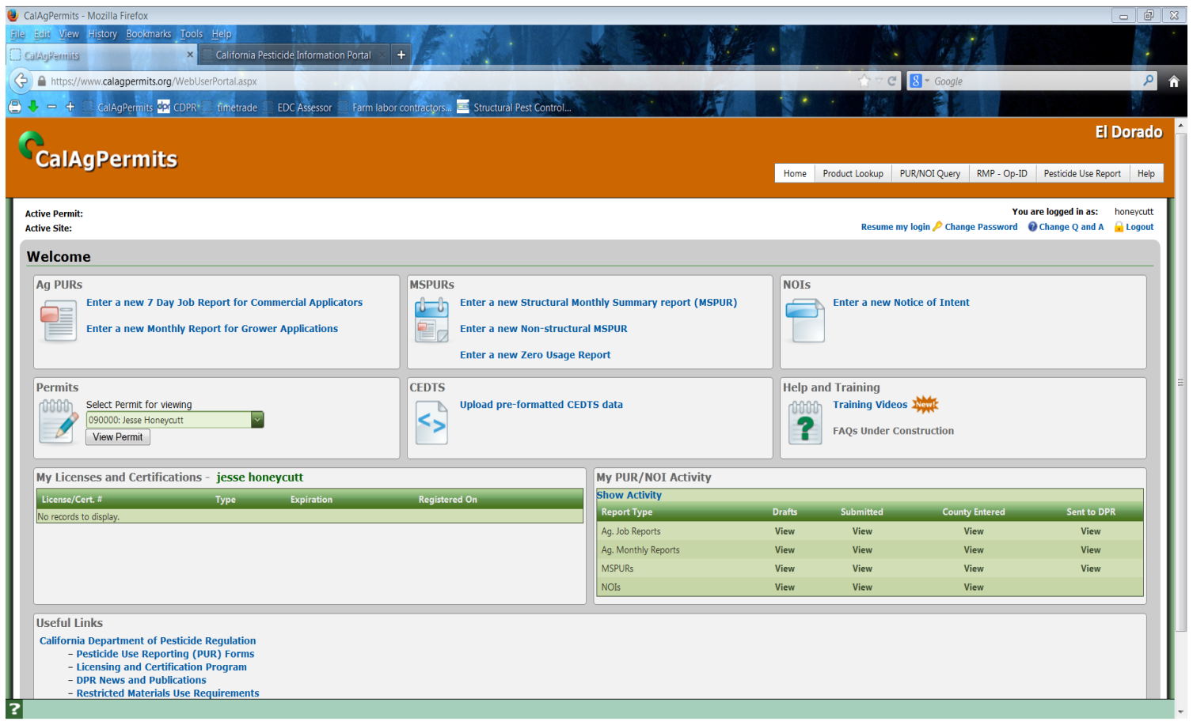**MSPURs**: This is used by landscaping and pesticide control businesses. Pesticide applications to buildings and other structures should be reported on the “**Structural Monthly Summary report (MSPUR)**.” Non-agricultural, non-structural pesticide applications (such as landscape, waterway and SO2 applications) are reported on the “**Non-structural MSPUR**.”

**Notice of Intents**: At least 24 hours notice is required by restricted materials permit holders (differs from an operator identification permit) before any application of California restricted materials.

**CEDTS:** Permit holders using a 3rd party management tool such as *Lady Bug, Tiger Jill* or *AgCode* can click on “**Upload pre-formatted CEDTS data**”to find, upload and send their PUR files directly to the County Agricultural Commissioner’s office.

**Permit:** Clicking on “**View Permit**” will pull up your current permit.